

*Volume 1 Issue 1* ***2024***

**The provision of psycho-social support for young people in Chitungwiza District. A case of SOS International, Zimbabwe**

Jonathan Mrewa1 and Precious Moyo1

1Tugwi-Mukosi Multidisciplinary Research Institute, Midlands State University, P. Bag 100 Zvishavane, Zimbabwe.

**Corresponding author**: [jonamrewa1974@gmail.com](mailto:jonamrewa1974@gmail.com)

**ABSTRACT**

The study sought to assess the provision of psycho-social support for young persons in Chitungwiza under the Family Strengthening programme spearheaded by SOS International. The study adopts a mixed method approach. Mixed research approach was used to establish empirical associations between indicators of psychosocial support in Chitungwiza. All participants in this study were 18 years and older.In total, 25 participants were involved in the study with 5 officers participating in semi- structured interviews and 20 young people completed questionnaires during the study. The research participants were chosen based on their knowledge and experiences of the phenomenon of psychosocial challenges among the youths in Chitungwiza district. A number of themes emerged on the provision of psychosocial support programmes during data collection and interpretation. The study revealed there are various dimensions of psychological and social issues affecting young people in the community that include mental, suicidal tendencies, anxieties and poor self-concept as well as sexual abuse and teenage pregnancies. Overall, in terms of seeking support, 50 % young people expressed concerns of being judged by service providers and community, 15 % indicated that lack of information is a factor; 15 % outlined that centres that provide services are sometimes far from where they live and 20 % of young people lack motivation to receive such support. One of the panaceas identified in the study to reduce psychosocial problems among young people, is community engagement and advocacy to deal with the social issues that triggers psychological challenges. In addition, it was highlighted that there is need establish more Youth Friendly Centres that can help in cascading psychosocial programmes for young people to deal with the challenges they face in their everyday lives.

**Key words**: Adolescence, counselling, drug abuse, empowerment, mental health

**Introduction**

There has been a growing global interest in psycho-social support for young people among governments, non-governmental organizations; United Nations Agencies (UNICEF, 2019; UNFPA, 2021) and researchers (Levy, 2022; Azhan and Suhaila, 2016; [Bradford](https://pubmed.ncbi.nlm.nih.gov/?term=Bradford%20S%5BAuthor%5D)and [Rickwood](https://pubmed.ncbi.nlm.nih.gov/?term=Rickwood%20D%5BAuthor%5D), 2012). Psychosocial support is embedded in “Psycho” that refers to the inner world of a person – their thoughts, feelings, and emotions while ‘social’ relates to the external world and environment of the person, and the relationships they have with this. Subsequently, psychosocial support work focuses on the aspects of an environment or situation which impact on both the social and psychological well-being of affected individuals (Papyrus, 2024). According to Madu (2015) psychotherapy focuses on modification of behaviours and psychological issues. Similarly, insight therapy entails that behaviour, emotions and thoughts can be disordered because people do not understand themselves when dealing with challenges that they experience in their everyday life. Emphasis on the psycho-social support is to allow people to truly discover themselves and make informed decisions about their lives. Afterwards, mental health services encourage individuals to reflect on their circumstances, emotions, and actions in a positive light (Bradford and Rickwood, 2012).

Some of the problems that face adolescents differ depending on where they live and are environmentally induced. For example, substance use, eating disorders, and lack of exercise are more prevalent in developed countries (Levy, 2022). Adolescence is a sensitive and critical period for both normal and maladaptive patterns of development. This period is formerly described as the time of transition from concrete operational thinking to formal logical thinking, including development in reasoning and judgement (Papyrus, 2024). New perspectives emphasize that adolescent thinking is a function of social, emotional, and cognitive processes (Steinberg, 2005). There is growing evidence that the brain continues to mature throughout adolescence and into early adulthood (Gogtay et al. 2004). During this period, brain, behavioural, and cognitive development systems mature at different rates, causing adolescence to be a period of increased vulnerability and adjustment (Levy, 2022).

Like some other countries in Africa, Zimbabwe experiences drug abuse problems especially among the youths. The negative effects of this problem have been felt by the drug abusers, their families, communities and nation at large (Chikoko, 2019). Zimbabwean youth (10-35 years) are the most affected age groups by drug abuse (Nhunzvi et al. 2019; Rwafa, 2019; Nhapi, 2019) and this age group constitutes 67.7% of the total population (Zimbabwe Human Rights Commission, 2018). Zimbabwe’s population is generally young (Zim stat, 2022). In the 2020 Census, 62% of the Zimbabwean population was below the age the ages of 25 years (Zim stat, 2022). According to the ZimStat 2022 second quarter labour force survey about half of Zimbabwean youths is unemployed. Results of the Zim Stat survey of 2022 shows that the national proportion of youths aged between 15 and 34 years who were not in employment, education or training (NEET) was estimated at 50%, while the proportion of those aged between 15 and 24 in the same category stood at 49%. The national unemployment rate for youth between 15 and 34 years was 29%, while the youth aged between 15 and 24 had a national unemployment rate of 37% (Zim stat, 2022). Therefore, the young demographic is at risk of psychosocial challenges that require focus, as they could potentially turn to substance abuse because of the high levels of unemployment.

The provision of Psychosocial support helps reinforce defensive factors for the child, including their ability to identify dangerous and risky situations. Subsequently, Psychosocial support can help promote holistic child and adolescent development, including physical, emotional and social development (UNICEF, 2022). Thus, Psychosocial support, provides life skills activities to help strengthen young people’s resilience and their ability to cope with difficult situations.

A crucial factor for the growth of human capital is effectively managing emotions. One of the ways to manage emotions among young people is through a psycho-educational approach in group counselling. Counselling is a process that helps individuals form new dimensions of thinking, behaviour, and emotion (Azhan & Suhaila, 2016). In addition, counselling plays a role in helping individuals identify and explore their potential. Whereas psycho-education is a systematic education of the processes and factors associated with human education (Ahmad, 2013). Therefore, psycho-educational groups play a similar role as counselling and psychotherapy in shaping individuals in a more positive direction.

Good emotional management is a prerequisite for human capital development. One of the ways to manage emotions among adolescents is through a psychoeducational approach in group counselling. Counselling is a process that helps individuals form new dimensions of thinking, behaviour, and emotion (Azhan and Suhaila, 2016). In addition, counselling plays a role in helping individuals identify and explore their potential. Whereas psycho-education is a systematic education of the processes and factors associated with human education (Ahmad, 2013). Therefore, psycho-educational groups play a similar role as counselling and psychotherapy in shaping individuals in a more positive direction. Recent studies such as the one by Rafidi, et al. (2015) found that group counselling programs can increase the motivation of drug addicts in rehabilitation centres. Similarly, Falco et al. (2014) also found that counselling for children of divorced parents is an effective therapy as it provides a mechanism for them to talk about their feelings and experiences thus reducing their negative feeling.

Verbal therapy is another important strategy that can be used to provide psychosocial support to young people. Significantly, counselling interventions involve a variety of media and techniques that help clients express themselves. One of the most creative approaches supported by professionals includes art therapy. Tripathi and Dilawari (2012) define art therapy as a form of projective technique that uses the creative process of art to enhance the physical, mental and emotional well-being of individuals of all ages. This is in line with the study conducted by Zuria et al. (2018) using creative interventions in solving bully problems among female students.

A school guiding and counselling programme is a necessary activity throughout the schooling period. It was also observed that adolescents consider that the existence of a counselling centre is beneficial to any school, that it is necessary to carry out guidance and counselling activities in school, that these activities are important for people's success in life (Zechmeister et al. 2008). Thus, students claim that the hours intended for counselling should be those of leadership, but also those after school, considering that the absence of the activity of a school counsellor would cause difficulties in identifying students who need differentiated education (Larson et al. 2002). None of the participants considered the option that counselling programs are not required.

The Empowerment framework is found useful in unpacking the issues of psychosocial support for young people. The theoretical model is essential for understanding the process and consequences of efforts to exert control and influence over decisions that affect one's life, organizational functioning, and the quality of community life (Bennett-Cattaneo and Chapman, 2010; Zimmennan and Warschausky, 1998). A distinction between the values that underlie an empowerment approach to social change and empowerment theory is necessary. The value orientation of empowerment suggests goals, aims, and strategies for implementing change. Empowerment theory provides principles and a framework for organizing our knowledge. Empowerment suggests a distinct approach for developing interventions and creating social change (Virginia Commonwealth University, 2021). It directs attention toward health, adaptation, competence, and natural helping systems. It includes the perspective that many social problems exist due to unequal distribution of, and access to, resources (Zoabi and GaL, 2019). An empowerment approach goes beyond ameliorating the negative aspects of a situation by searching for those that are positive. It seeks to facilitates a person’s self-confidence, self-esteem and sense of personal agency. It centres on skills development, acquisition of knowledge and promoting positive to individuals to be able to take control of their lives in making informed decision and manage crisis in their lives (Martinez, 2023). Thus, enhancing wellness instead of fixing problems (Cowen, 2005), identifying strengths instead of cataloguing risk factors, and searching for environmental influences instead of blaming victims characterizes an empowerment approach.

Individuals need to develop a deep understanding of the complex social, economic and political realities in their environments that negatively affect them. This involves examining their roles in these environments and seeking out potential ways to work around the structures blocking them. Establishing this type of consciousness allows people to share their experiences and connect with others in the same or similar situation (Virginia Commonwealth University, 2021). Counsellors can guide individuals through therapies that help clients explore their beliefs, why they hold them, and how to change them. They can also help individuals develop coping skills to adjust to their environments (Zuria et al. 2018).

In general, studies on psychosocial support on a global scale have been carried out looking at the sexuality counselling for young persons, in particular, literature review points out on the relevance of school counselling on adolescents’ sexuality issues (Anameze, 2002; Larson et al. 2002). The other strand of studies looks at the impact of adolescence challenges on human growth and development (Rice, 2022; Brook et al., 2011). A clear understanding of the problem of psychosocial counselling is essential to bridge the knowledge gap on the proliferation of the psychosocial problems affecting young people in Chitungwiza. The study is unique as it explores the psychosocial counselling support of young people. It is time to question how psychosocial problems are affecting young people to enjoy their full development and achievement in the community. Therefore, the objectives of the were: a) to analyze the importance of psychosocial support for young people. b) to identify intervention measures that can promote the provision of psychosocial support services for young people.

**Research Methodology**

This study adopted a mixed-method approach. Mixed research refers to a research approach that involves the blending of qualitative and quantitative approaches as well as other paradigm tenets (Johnson & Christensen, 2014). As such, given the nature of the phenomenon under study, mixed research approach is found suitable because it helps to improve the quality of for the phenomenon under study since it mixes up the strengths of both qualitative approach and quantitative approach (Creswell and Creswell, 2018). Mixed research is a tool that the current study used to establish empirical associations between indicators of psychosocial support in Chitungwiza (Stockemer, 2019). As Johnson & Christensen (2008) assert, mixed research`s major strength is that of generalizability of findings to other population. It is worth noting that mixed approach has been found useful and appropriate since it requires the reduction of phenomenon under study to numerical values which calls for statistical analysis of data as well explanatory and feedback which calls for qualitative data analysis thus convergent of QUAN and QUAL data analysis (Apuke, 2017).

The sample size for this research was 25 participants (20 young people and 5 officers from the Department of Social Service and SOS International), calculated using online sample size calculator at 95% confidence level; 5% margin of error from a population of 200. This is true for QUAN. However, under QUAL, the sample size was determined at saturation point. This study used structured questionnaires for 20 young people from the 200 young people who participated in the programme and 5 project staff (3 from SOS International and 2 officers from the Department of Social Services (DSS) participated in Semi structured interviews. Officers from DSS and officers from SOS International were chosen because they have been jointly monitoring implementation and impact of psychosocial support services for young persons in Chitungwiza. For data generated through QUAL approach, the interviews recorded were transcribed manually by the researcher. Content analysis was used as a means of analyzing data collected by way of semi-structured interviews. Themes and sub-themes were developed, analyzed and interpreted such that meaningful information can be generated. It is also important to note that after QUAN data analysis, and QUAL data analysis, the results from both approaches was compared to determine whether there is convergence, differences, or combinations.

**Results and Discussion**

**Nature and context of problems affecting the provision of psycho-social counselling for the young people.**

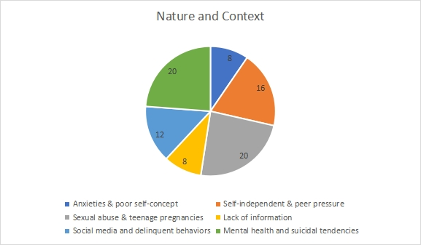Figure 1: Nature and context of the problem1

There are various dimensions of psychological and social issues highlighted by respondents concerning the psychosocial nature of the problems that affects young people in the community. In the study, 20% of respondents indicated that mental health and suicidal tendencies are the problems that affect young people in the community; 8% attributes anxieties and poor self-concept as the problem. Similarly, 8% refers self-independent and peer pressure as the nature of the problem, 20% identified sexual abuse & teenage pregnancies as challenges 8% of respondents identified lack of information as a cause. In addition, 12% of the respondents outlined social media and delinquent behaviours as the nature of the problems in the community. In most cases, the nature of the problems highlighted revolve around psychological and social issues that are common in the community. This is collaborated by literature review that points out that there is also mounting concern about the level of self-harm among young people. The act of suicide or self-harm is usually thought to be symptomatic of significant mental health difficulties, such as depression, anxiety or stress (Miller and Glinski, 2000), as well as certain underlying maladaptive thought processes. A lack of self-efficacy in one’s ability to cope with difficulties may lead to a sense of hopelessness (Townsend et al. 2001).

**Existence of young persons affected by psychological and social problems in the community**

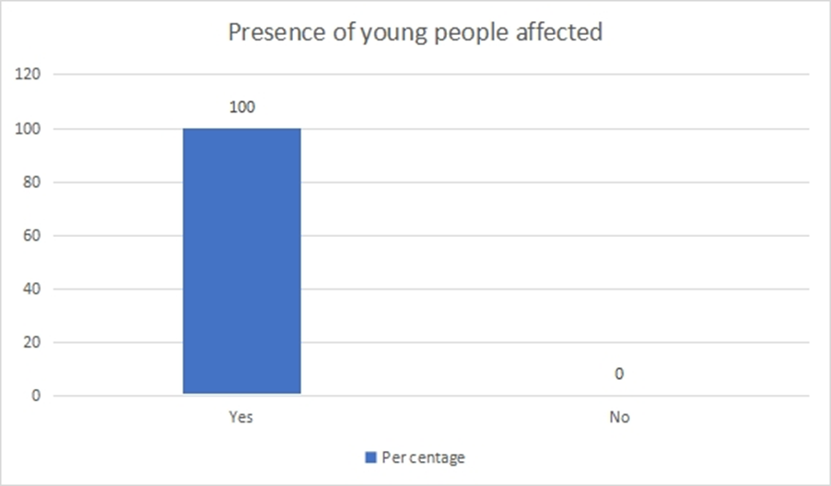

Figure 2: Young people affected by psycho-social problems

In the study 100% of the respondents indicated that in the community they live in, there are a number of young people who face psychosocial challenges. The problem of psychosocial issues come in various dimensions and young people are facing these challenges in the communities they live. The views and responses are collaborated by literature that points out that accumulation of problems also pose challenges for the development of interventions targeting young people. When problems accumulate, there is need to the support the young person comprehensively, rather than focusing on one single symptom or problem behaviour only (Townsend, 2001). As an example, a young person has to be viewed from various perspectives, such as psychological and physiological well-being, interpersonal relations, life situation and future plans, economic situations, living conditions, healthy way of life and leisure time activities. Subsequently, a young person not in full-time work or education can have complex needs. Besides mental distress, they can face substandard housing, financial difficulties and a lack of opportunities for developing independence and social engagement. Hence, looking at the nature of the community of Chitungwiza, there are various problems that already characterize the community ranching from high levels of unemployment, teenage pregnancies and drug and substance abuse.

**Community’s attitude towards the provision of the psycho-social counselling**

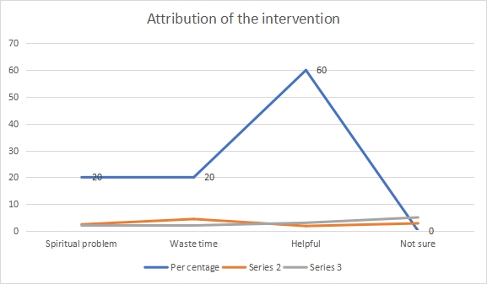

Figure 3: Community Attitudes towards support

In the study, respondents gave diverse perspectives about the psychosocial programme that is being offered at community level. In the study, 60 % respondents attributed psychosocial support as helpful, 20% of respondents attributed psychosocial problems to the spiritual issues. At the same time, 20 % of respondents view psychosocial programme as a waste of time because parents have failed to look after their children. One respondent said, “such *programmes are a mere waste of time because parents and families have failed to rehabilitated their children who takes drugs, it is difficult for a stranger to help such individual”.* Another respondent had different view of the role of the programme, “such *programmes are useful to our community because we have many young people who are taking drugs and engaging in illicit sexual activities. If the young people can receive such support, it will go a long way to reduce high incidences of substance abuse in the community”.* These varied responses are crucial in understanding the community views on the dimensions of psychosocial issues. The responses are collaborated by literature review that points out that myths and beliefs about mental health and psychosocial challenges are ubiquitous in every community which influences people’s attitudes (Denise, 2012). Most of the African societies’ attitude towards mental health is far from the scientific view which may negatively affect treatment-seeking and treatment adherence. Conversely, others in the community see psychosocial support as an empowerment strategy that strives to empower individuals so they can overcome personal challenges such as substance abuse or eating disorders, personal or family illness, and the emotional trauma resulting from divorce, abuse or the death of a loved one (Virginia Commonwealth University, 2021).

**Young people’s attitude toward the provision of the psycho-social counselling**

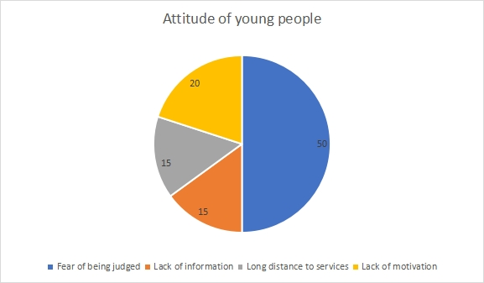

Figure 4: Attitude of young people to the programme

In the study, respondents revealed varied attitudes of young people towards the provision of psychosocial support services to young people. Subsequently, 50 % indicated fear of being judged by service providers and community, 15 % indicated that lack of information is a factor; 15 % outlined that centres that provide services are sometimes far from where they live and 20 % of young people lack motivation to receive such support. From the study, 50 % of the youths indicated that they are not comfortable to receive support at youth friendly centres. Such views are collaborated by literature that states that one of the perceptions affecting youth’s attitude towards accessing youth friendly services is the fear of being judged. Research carried out in the Northern part of Nigeria suggested that that young people’s access to youth friendly facility may be restricted due to the cultural and religious beliefs of the societies to which these adolescents belong” (Adeokun et al. 2009). Many communities frown at psychosocial support services, as such, young people will be criticized if they even attempted to access youth friendly services. This can also be supported by a publication by World Health Organization (2001) which stated that “harsh culture against the use of reproductive services by young people affects their perception towards youth friendly facilities. The attitude of counselling providers towards young people seeking reproductive services and other psychosocial services can also affect their perception. “Many healthcare providers have unfavourable attitudes towards the provision of contraceptives for unmarried adolescents” (Ahanonu, 2014). Consequently, there is need for change of attitude by service providers to accommodate the young people who seek help so that their attitude for such services becomes positive.

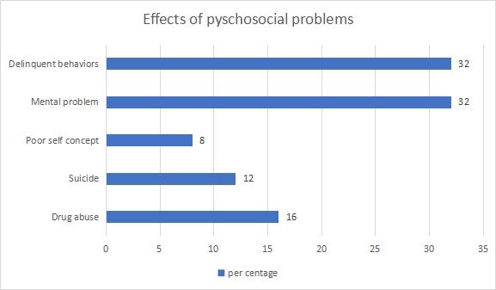**Consequences/ effects of psychological and social problems for the young person**

Figure 5: Effects of psychosocial problems

The consequences of psychosocial problems are wide-ranging. In the study, 16 % of respondents identified drug and substance abuse as a resultant factor; 12 % attribute suicide and 8 % of respondents outlined poor self-concept as a consequence. In addition, 32% of respondents indicated that mental health problems are a direct effect and 32% of respondents indicated that the resultant effect of psychosocial problems are delinquent behaviours among the young people. The consequences of unmanaged psychological and social issues have dire effects to the young people. Such views are collaborated by literature review that points out thatyoung people are particularly vulnerable to social exclusion, notably in the transition stage between education and employment. For example, leaving school early without access to full time work can lead to disconnection economically and socially and failure to develop a sense of the future. These young people form a specific category of “invisible” young people, as their possibilities and rights to a minimum income or health insurance are in many countries only minor (UNICEF, 2013). Compared to adults, young people are especially at risk of creating vulnerabilities or developing mental health disorders as they face many new pressures and challenges in their daily lives. Leaving the parental home for the first time, financial worries, limited employment or educational opportunities or worries with human relations can cause high levels of stress, which can trigger mental disorders. Several disorders, such as depression, schizophrenia and substance abuse are identified as having their onset at this age (WHO, 2001).

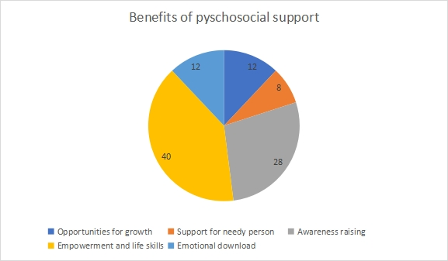**Benefits that are derived from psychosocial support for young people**

Figure 6: Benefits of psychosocial support

The provision of psychosocial programmes has an avalanche of benefits to young people as highlighted by the responses in this study. In the study, 8% of respondents indicated that psychosocial support empowers the needy person, 12 % identified opportunities for growth in the provision of psychosocial support and 28 % noted that such programmes provide awareness to the dangers of engaging some of the illicit activities such as drug abuse. In addition, 40% of the respondents outlined that such programmes are a pyramid of empowerment and life skills coaching.

One respondent said, *“the benefits of psychosocial support include changing the behaviours of young people who are delinquent in the community and it allows young people to make meaningful choices in life”.* Another respondent noted that *“the programme is an awareness strategy for the young people to report and respondent to cases of abuse in the community”*

Such views are collaborated literature review that suggests that social support is a set of procedures in resource provision and/or exchange between the individual and others, which include family members, peers, and significant others (Gabert-Quillen et al. 2011). An individual receiving decent social support gets relief from post-traumatic stress disorder (PTSD) symptoms as well as depression, in addition to a boost in well-being while maintaining mental health

stability (Roslan et al., 2017; Whitley et al., 2016). Good emotional management is a prerequisite for human capital development. One of the ways to manage emotions among adolescents is through a psycho-educational approach in group counselling. Counselling is a process that helps individuals form new dimensions of thinking, behaviour, and emotion (Azhan and Suhaila, 2016). In addition, counselling plays a role in helping individuals identify and explore their potential. Whereas, psycho education is a systematic education of the processes and factors associated with human education (Ahmad, 2013). Consequently, provision of counselling services become imperative in order to provide guidance and support for the young people who might end up making wrong decisions especially those that deals with sexuality matters.

**Mitigation measures to reduce incidences of psychological and social problems among the young people.**

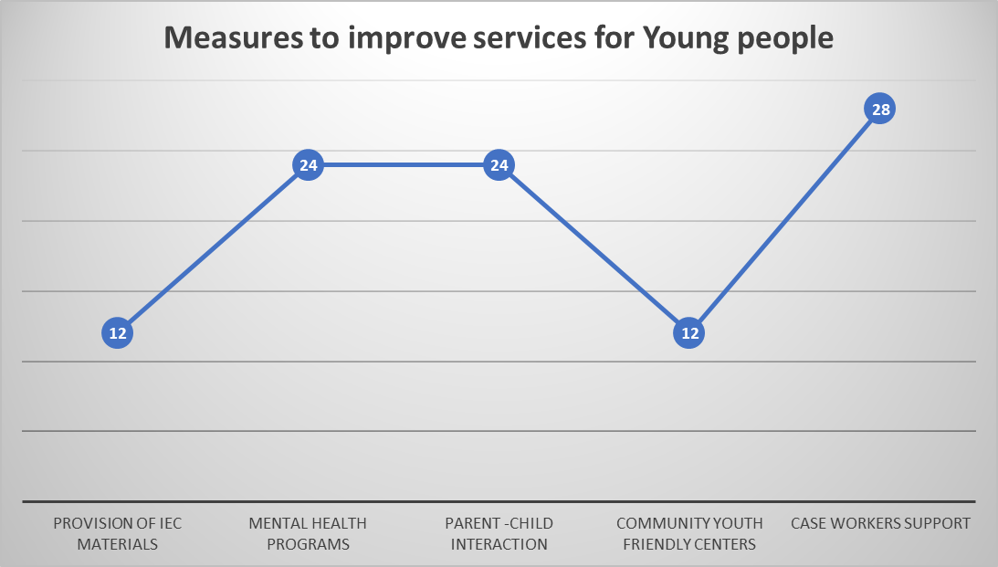

Figure 7: Measures to improve psychosocial services

The study revealed that there are a number of ways to improve psychosocial programmes for young people in the community. In the study, 24 % of the respondents indicated that the provision for Information Educational and Communication (IEC) materials is vital for the programme; 24 % of respondents indicated that provision of robust mental health programmes is important and 12 % indicated that the programmes can make a difference when child – parent positive interactions is incorporated. In addition, 12 % of respondents indicated that the role of Community Case Care workers should be more pronounced and there is need to establish more Community Youth Friendly Centres to support the programmes of psychosocial support.

One respondent had this to say: *‘psychosocial programmes can be improved through engaging families where these young people are coming from. The role of the parent should be considered so that any interventions that a child can participate in has a buy in of the parent.’* Another respondent had this to say, *‘psychosocial programmes can be improved through the works of case care workers who are resident in the wards they operate in. These people understand the challenges that the young people face as they interact with the young people every day.’* Such views are collaborated with literature review that states that establishing a positive relationship is the basis of practice in all aspects of casework with children, young people and families (Trotter, 2004; Davis et al., 2002). In the Caseworkers Study, participants described casework practice with adolescents as a collaborative process of “walking it together” with the young person. In this process, the caseworker is the “common denominator”, linking the adolescent, their family and other services or agencies. The caseworker’s key role is to build and maintain a relationship with the young person and, as appropriate, their family in order to facilitate engagement in services (Schmied and Walsh, 2007). In addition, the importance of the participation of both the young person and their parent/s is critical in psychosocial support programmes. Parents are appropriate and supportive role models for the adolescent and that family members involved in treatment need to be fully engaged, otherwise their involvement may have a detrimental effect on the outcome of the intervention this may not always be the case (Huey et al. 2004).

**Conclusion and Recommendations**

The study concluded that psychosocial programmes are an integral component in uplifting the lives of young people in the community in order to acquire skills that can help them to overcome some of the challenges they face in their everyday lives. It is also concluded that young people have diverse views about the provision of psychosocial services. Some of the respondents indicated that they fail to seek psychosocial services because they fear to be being judged by service providers and community. In addition, some youths are not aware of such interventions as they lack access to information and others are not motivated to get such support services.Thus, there is need for change of attitude by service providers to accommodate young people who seek help. Availability of psychosocial support at community level is critical in reducing incidences of psychosocial problems among the young people.

The research suggests that increasing awareness and promoting a positive perception of psychosocial support services is important. This should done through advocacy work and engagement with youths in the communities. There is need for the Ministry of Youths to establish business hubs that are useful for practical trainings for young people so that young people can run some business and projects that can kept them occupied away from drugs and substance abuse. The other recommendation is that there is need for the government to establish more Youth Friendly Corners in the districts for young people to access such services. In addition, those who work in such centres need to be professional and be friendly to young people so that they are not scared to access seek support.

**Data Availability**

Data collected will be de-identified and the identifiers stored in a separate location. Data to be encoded or anonymized as much as possible and be consistent with the needs of the study. Electronic data to be stored on a password protected hard drive.

**Conflicts of Interest**

The author(s) declare(s) that there is no conflict of interest regarding the publication of this paper

**Funding Statement**

The research was funded from personal funds.

**References**

Anameze, L. N. (2002). Sex education and marriage counselling with goals, contents and methods. Jos Plateau, Nigeria: Fab. Anieh Ltd.

Araniego, J. (2003). Counselling services. Retrieved 08, 2023 from http://isis.fastmail. usf.edu/counsel/personal.htm.

American School Counselor Association. (2009). The role of the professional school counselor. Retrieved from http://www.schoolcounselor.org/asca/media/asca/ home/rolestatement.pdf.

Alger, A. L., and Luke, M. (2015). The school counselor perspective: Preparing students to be college and career ready within a comprehensive school counselling program. Practitioner Scholar: *Journal of Counselling & Professional Psychology*, 4(1), 17–35.

Barnett, J.E. (2007). Boundary issues and multiple Relationships: Fantasy and reality. Professional Psychology: *Research and Practice*, 38(4), 401-405.

[Bradford](https://pubmed.ncbi.nlm.nih.gov/?term=Bradford%20S%5BAuthor%5D), S and [Rickwood](https://pubmed.ncbi.nlm.nih.gov/?term=Rickwood%20D%5BAuthor%5D), D. (2012). Psychosocial assessments for young people: a systematic review examining acceptability, disclosure and engagement, and predictive utility. [*Adolesc Health Med Ther*.](https://www.ncbi.nlm.nih.gov/pmc/articles/PMC3915791/)  3: 111–125.

Bennett-Cattaneo L, Chapman AR. (2010). The process of empowerment: A model for use in research and practice. *American Psychologist,* 65(7),646-659

Creswell, J.W. (2003). Research design, Qualitative, Quantitative and mixed methods approach (2nd ed.). London: SAGE Publications.

Griffiths, F., Lindenmeyer, A., Powell, J., Lowe, P., and Thorogood, M. (2006). Why are health care interventions delivered over the Internet? A systematic review of the published literature. *Journal of Medical Internet Research*, 8(2), e11.

Grills, C.T. (2006). Strategies for Psychological Survival and Wellness. *Journal of African Centred Psychology,* 8(1), 26-43

Gone, J. P. (2010). Psychotherapy and Traditional Healing for American Indians: Exploring the Prospects for Therapeutic Integration. *Journal of the Counselling Psychologist,* 38(2), 166- 235

Hines, P. L., Lemons, R. W., and Crews, K. D. (2011). Poised to lead: How school counselors can drive college and career readiness. K–12 Practice. The Education Trust. Retrieved from <http://eric.ed.gov/?id=ED527908>

Ibrahim, F. A. (2011). Teaching strategies for group work: Addressing cultural responsiveness and social justice. In Singh, A., & Salazar, C. (Eds.), Social justice in group work (pp. 188-215). London, UK: Routledge, Taylor & Francis Group.

Johnsen, J.-A. K., Rosenvinge, J. H., & Gammon, D. (2002). Online group interaction and mental health: An analysis of three online discussion forums. *Scandinavian Journal of Psychology*, 43(5), 445-449. [https://doi.org/10.1111/1467-9450.00313](https://psycnet.apa.org/doi/10.1111/1467-9450.00313)

Kummervold, P.E., Gammon, D., Bergvik, S., Johnsen, J.A.K., Hasvold, T., and Rosenvinge, J.H. (2002). Social support in a wired world: Use of online mental health forums in Norway. *Nordic Journal of Psychiatry*, 56, 59 - 65.

Lange, A., Van den Ven, J.P., and Schrieken, B. (2003). Inter - therapy: Treatment of post-traumatic stress via the internet. *Cognitive Behaviour Therapy*, 32(3), 117-124.

Levy. M. (2022). School Problems in Adolescents. Boston, USA, Harvard Medical School.

Madu, S. N. (2015). Psychotherapeutic values for modern Africa. *World Journal of Psychotherapy,* 8, 8-15.

Mallen, M.J., Vogel, D.L., Rochlen, A.B., and Day, S.X. (2005). Online counseling: Reviewing the literature from a counselling psychology framework. *The Counselling Psychologist*, 33, 819 - 871.

McMahon, H. G., Mason, E. M., and Paisley, P. O. (2009). School counselor educators as educational leaders promoting systemic change. *Professional School Counselling*, 13(2), 116-124. doi:10.5330/PSC.n.2010-13.116

Omeje, J. C. (2003). The role of counseling in improving instruction in tertiary institution: A case study of University of Nigeria, Nsukka. *The Journal of World Council for Curriculum and Instruction* (Nigeria Chapter, WCCI), 4, 83-91.

Michaud, P., and Colom, P. (2003). Implementation and evaluation of an Internet health site for adolescents in Switzerland. Journal of Adolescent Health, 33, 287 - 290.

Proudfoot, J., Goldberg, D., Mann, A., Everitt, B., Marks, I., and Gray, I.A. (2003). Computerised, interactive, multimedia cognitive-behavioural program for anxiety and depression in general practice. *Psychological Medicine*, 33, 217 - 227.

Reynolds, D., Stiles, W.B., and Grohol, J.M. (2006). An investigation of session impact and alliance in Internet based psychotherapy: Preliminary findings. *Counselling and Psychotherapy Research*, 6(3), 164 -168.

Rubin, A., and Babbie, E. (2001). Research methods for social work, 4th edition. Belmont, CA: Wadworth/Thomas Learning, USA

Simpson, S., Bell, L., Mitchell, D., Britton, P., Morrow, E., Johnston, L., and Brebner, J. (2006). Does video therapy work? A single case series of bulimic disorders. *European Eating Disorders Review*, 14, 226 - 241.

Suler, J. (2004). The online disinhibition effect. *Cyber Psychology & Behaviour*, 7(3), 321- 326.

Tate, D.F., & Zabinski, M.F. (2004). Computer and internet applications for psychological treatment: Update for clinicians. *Journal of Clinical Psychology*, 60(2), 209 -220.

UNICEF (2019). Mental Health and Psychosocial Technical Note. Published by UNICEF 3 United Nations Plaza New York, NY 1001.

Wolf, M., Kordy, H., Maurer, W., Dogs, P., & Arikan, M. (2006). Mid- and long-term outcome of an e-mail aftercare program for psychotherapy inpatients. Paper presented at the Annual Meeting of the Society for Psychotherapy Research, Edinburgh.

Zetterqvist, K., Maanmies, J., Stron, L., & Andersson, G. (2003). Randomized controlled trial of internet-based stress management. *Cognitive Behaviour Therapy*, 32(3), 151 - 160.